**Order Management System**

The word has spread about your successful implementation of the order management system (OMS) for Starbuzz Inc.

You received an email from the manager of TastyPizza Inc. who heard about your success. He wants you to implement a new OMS for his pizza delivery shop. For the first milestone, he has defined several requirements that need to be fulfilled by your OMS:

• The shop offers pizza, several beverages (lemonade, water and wine) as well as some franchise items (shirts, mugs). The system needs to be able to represent these products.

• All products have a price and pizza and beverages have specific nutrition facts.

• Every pizza contains at least cheese and tomato sauce (Pizza Margherita). It can be combined with additional

toppings (ham, onions, etc.), which can be ordered multiple times.

• Pizzas with certain topping combinations are named, e.g., Hawaiian Pizza for the base pizza with ham and pineapple. Those names should be contained in the bill. You do not need to auto-detect names for such combinations if they are not explicitly requested in the order.

• In addition to the normal size, pizza can be ordered in family size.

The manager sent you the menu card of TastyPizza for a better understanding of their available items:

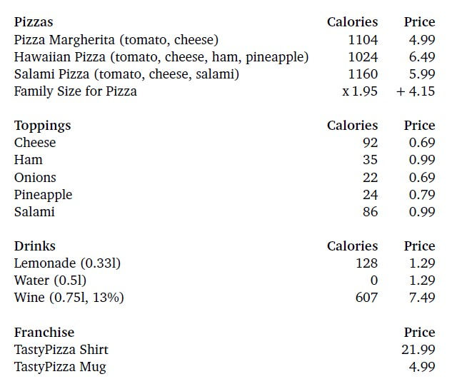

Your tasks for this exercise are as follows:

• Use the Decorator Pattern to implement the different variations of pizza (additional toppings, family-sized).

• Create a UML [class diagram](https://cms.greenwich.edu.vn/mod/resource/view.php?id=7402) that illustrates your design.

• Use C# to implement your design

• Write the report for the lab